II B. Tech I Semester Regular Examinations –December, 2023
DIGITAL ELECTRONICS
Time: 150 Min (ECE) Max. Marks: 80M

SECTION – A
Answer all Four questions 4×10M=40M
- Design a Gray code incrementer, which is a circuit that accepts a 4-bit Gray code A₃A₂A₁A₀ as input and outputs the Gray code B₃B₂B₁B_{0.} For the next number rolling over to the representation of (0)₁₀ if the input represents (15)₁₀.
- Construct the truth table for this circuit showing the outputs as functions of the inputs. [3M]
- Write down a valid sum-of-products Boolean expression for each of the outputs. Then, using the laws of Boolean algebra, simplify the expressions. [3M]
- Implement the minimized expression using logic gates [4M]

- Design a combinational logic circuit to display your birthday date ex. 27-10-2017 in a serial fashion through a 7 segment display unit
  - Generate a truth table for this circuit [3M]
  - Obtain the minimized output expressions [3M]
  - Implement the design using logic gates. [4M]

- Consider the Master-Slave flip-flop implemented with D-latches.
  - Complete the timing diagram template in figure 1 for the given inputs [3M]
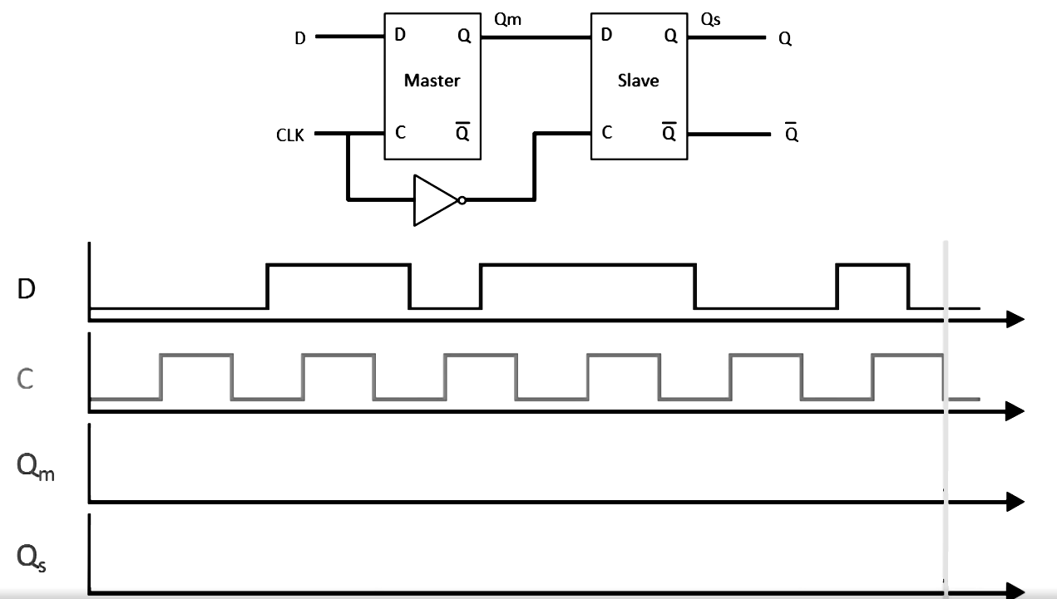
Figure 1: Master slave D
FF and its to be completed timing diagram
  - Mention the characteristic equations for T and JK flip-flops, Implement T and JK flip-flops with D flip-flops and 2 to 1 multiplexers. [4M]
  - Complete the timing diagram mentioned in figure 2 for the given flip-flop inputs. Consider the flip-flop has positive edge triggering and asynchronous active low clear. [3M]
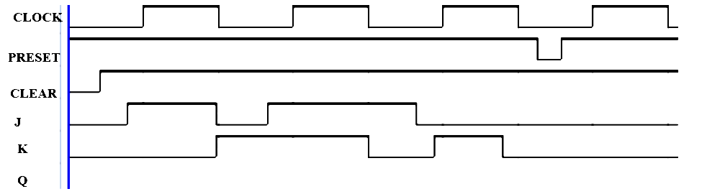
Figure 2: To be completed timing diagram
- Design a synchronous counter that counts the following sequence of numbers: 0, 2, 4, 6, 1, 3, 5, 7, 0, 2 ... The counter has an active high input (E) that controls the behaviour of the counter as follows:
- If E=1, the counter moves to the next state.
- If E=0 the counter stays in the current state.
Moreover, the counter has an output (Z) that is equal to one when the counter reaches the state. Use clocked D-F.F.s and any additional necessary logic gates.
- Write down the excitation table of the D flip flop. [2M]
- Draw the state diagram and specify how many flip flops are required to build this counter? [4M]
- Write down the transition table to find the equations of the flip flop inputs and realise the equations in the form of logic circuit. [4M]
SECTION - B
Answer all Two questions 2×20M=40M
- Build the Boolean function F(W, X, Y, Z) = ∑(1,3,4,11,12,13,14,15) using
- a 8x1 multiplexer and logic gates. [6M]
- a 4x1 multiplexer and logic gates. [6M]
- two 3-to-8 decoders with enables and logic gates. [8M]
- Design a coffee vending machine using Moore finite state machine considering the following points.
- Machine should remain in the initial state until a coin is inserted. [6M]
- It accepts either Rs 5 or Rs 10 coin at a time until it makes a sum of Rs. 15. [6M]
- Once Rs 15 or more is received it should generate coffee and doesn’t provide any change for the excess amount received. [8M]

